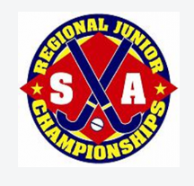

**Regionals**

**Coaching and Managers**

**Expression of Interest**

**Held in Naracoorte Friday night 29 Sept to Sunday 1 October 2023**

If you are interested in coaching or managing a team for the 2023 Regionals Competition, please fill out this form and email it to [scjuniorhockey@yahoo.com](mailto:scjuniorhockey@yahoo.com), hand it to your junior coordinator or to Wendy Huntington (south Coast junior coordinator).

|  |  |
| --- | --- |
| Name: | Home Number |
| Address:  Post address if different: | Mobile Number |
| Occupation: | Email Address: |
| Teams you have coached /managed: | |
| This position requires a police clearance for working with minors. Please state what level of clearance and the year it was obtained. | |
| Please circle or highlight the position/positions you are interested in. Please mark your first and second choice of teams as we may not be able to take all age groups. | |
| Under 13’s Girls Coach / Manager | Under 13’s Boys Coach / Manager |
| Under 16’s Girls Coach / Manager | Under 16’s Boys Coach / Manager |
| Under 19’s Girls Coach / Manager | Under 19’s Boys Coach / Manager |

I acknowledge that the above information is true and correct.

I will abide by the SCHA Code of Conduct, their Constitution and their Policies.

|  |
| --- |
| Name: |
| Signature: |